

DEPARTMENT OF INFORMATION TECHNOLOGY 24ITT32 - PROGRAMMING IN JAVA

INDIVIDUAL PROJECT ON ACADEMIC MANAGEMENT SYSTEM

P R O J E C T R E P O R T
Submitted by
VISHRUTHAA VR 25ITR177

JAVA ASSIGNMENT

AIM:
To develop a Kongu Engineering College (R2024) Student Academic &
Continuous Evaluation System using Java JDBC.

OBJECTIVE:
Design and develop a database-driven Java application using JDBC to manage student records, perform incremental marks entry (Continuous Internal Assessments and End Semester Examinations), enforce attendance eligibility rules, and generate formal academic performance reports according to Kongu Engineering College (Autonomous) - Regulation 2024. System Requirements & Specifications.

FLOW CHART:
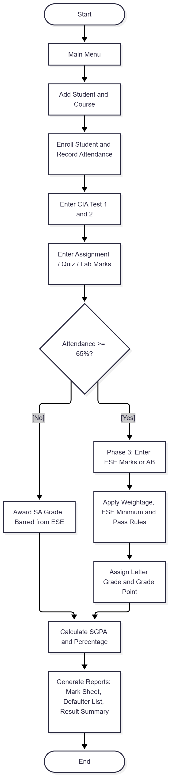

PROCEDURE:

- Install the JDK and MySQL, and add the MySQL JDBC driver (Connector/J) to the project’s classpath.
- Create the database kec_db and run kec_schema.sql to create the students, courses, enrollments and assessment_marks tables with primary key and foreign key constraints.
- Write DBConnection.java to load the JDBC driver and establish the connection to the database using DriverManager.
- Write AcademicDAO.java (or StudentDAO.java) with methods to:
  - add students and courses,
  - enroll students in courses and update total classes held and classes attended,
  - record CIA Test 1 and 2 (Phase 1), assignment/quiz/lab marks (Phase 2), and ESE marks or absence (Phase 3), using PreparedStatement for all queries.
- Implement the evaluation engine in the DAO:
  - Calculate the attendance percentage. Below 65% awards SA and bars the student from ESE, 65% to 74.9% is conditionally eligible, and 75% or above is eligible.
  - Apply the weightage by course type (Theory 40:60, Practical 60:40, Embedded 50:50).
  - Check the ESE minimum threshold and the overall pass mark of 50.
  - Assign the letter grade and grade point (O, A+, A, B+, B, RA, SA, AB).
- Calculate SGPA as the sum of (credits × grade points) divided by the total enrolled credits, and the equivalent percentage as SGPA × 10.
- Write MainApp.java as a menu-driven interface that calls the DAO methods for data entry, incremental marks entry and report generation.
- Compile and run the program, then add a student and a course, enroll the student, and enter attendance.
- Enter CIA 1 and CIA 2, then the assignment marks, and finally the ESE marks, checking the stored values after each phase.
- Generate the Student Semester Mark Sheet, the Attendance Defaulter Report and the Class Performance and Result Summary, and take screenshots of each step.

DATABASE SCHEMA:

- STUDENTS TABLE:
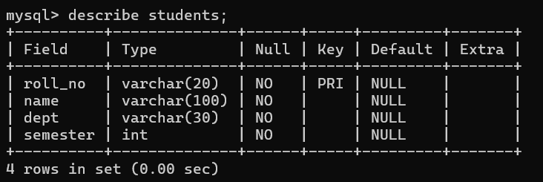

COURSES TABLE:

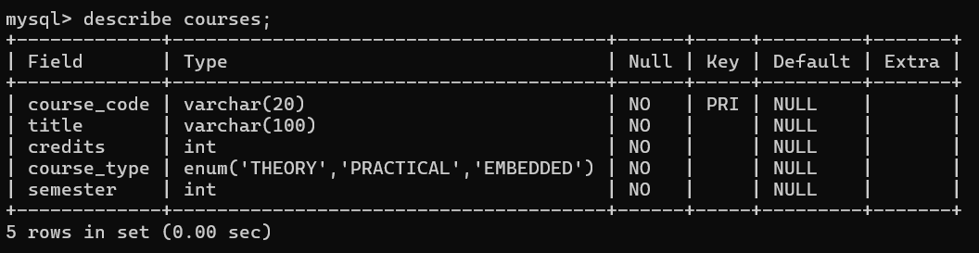

ENROLLMENTS TABLE:
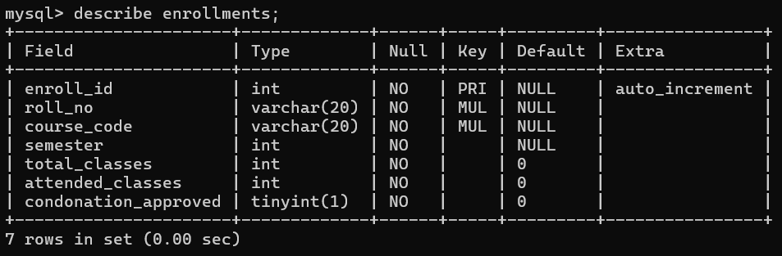

ASSESSMENT MARKS TABLE:
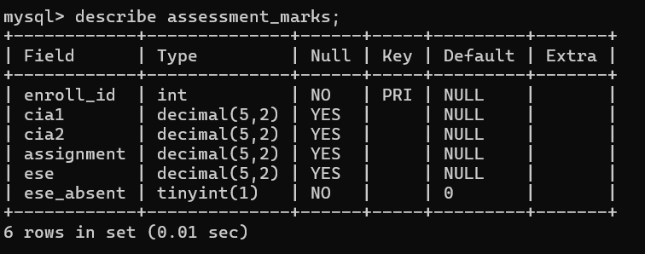

SOURCE CODE: MAINAPP.JAVA:
import java.sql.SQLException;
import java.util.List;
import java.util.Scanner;

public class MainApp {

private static final Scanner sc = new Scanner(System.in);
private static final AcademicDAO dao = new AcademicDAO();

public static void main(String[] args) {
int choice;
do {
printMenu();
choice = readChoice();

try {
switch (choice) {
case 1: addStudent(); break;
case 2: addCourse(); break;
case 3: enrollStudent(); break;
case 4: updateAttendance(); break;
case 5: enterCIA(); break;
case 6: enterAssignment(); break;
case 7: enterESE(); break;
case 8: markSheet(); break;
case 9: dao.printDefaulterReport(); break;
case 10: classSummary(); break;
case 11: condonation(); break;
case 0: System.out.println("Goodbye!"); break;
default: System.out.println("Invalid choice. Try again.");
}
} catch (SQLException e) {
if (e.getErrorCode() == 1062) {

System.out.println("Error: this record already exists.");
} else if (e.getErrorCode() == 1452) {
System.out.println("Error: that student or course does not exist. Add it first.");
} else {
System.out.println("Database error: " + e.getMessage());
}
}

} while (choice != 0);

sc.close();
}

private static void printMenu() {
System.out.println();
System.out.println("==============================================");
System.out.println(" KEC R2024 - Student Academic Evaluation");
System.out.println("==============================================");
System.out.println(" 1. Add Student");
System.out.println(" 2. Add Course");
System.out.println(" 3. Enroll Student in a Semester's Courses");
System.out.println(" 4. Update Attendance");
System.out.println(" 5. Phase 1: CIA Test 1 & 2");
System.out.println(" 6. Phase 2: Assignment / Quiz / Lab");
System.out.println(" 7. Phase 3: ESE Marks / Mark Absent");
System.out.println(" 8. Student Semester Mark Sheet");
System.out.println(" 9. Attendance Defaulter Report (SA)");
System.out.println(" 10. Class Performance & Result Summary");
System.out.println(" 11. Medical Condonation (65% - 74.9%)");
System.out.println(" 0. Exit");
}

private static int readChoice() {
System.out.print("Enter your choice: ");
try {
return Integer.parseInt(sc.nextLine().trim());
} catch (NumberFormatException e) {
return -1;
}
}

private static String readText(String prompt) {
while (true) {
System.out.print(prompt + ": ");
String s = sc.nextLine().trim();
if (!s.isEmpty()) return s;
System.out.println(" Input cannot be empty.");
}
}

private static int readInt(String prompt, int min, int max) {
while (true) {
System.out.print(prompt + ": ");
try {

int v = Integer.parseInt(sc.nextLine().trim());
if (v >= min && v <= max) return v;
System.out.println(" Enter a number between " + min + " and " + max + ".");
} catch (NumberFormatException e) {
System.out.println(" Please enter a valid whole number.");
}
}
}

private static double readDouble(String prompt, double min, double max) {
while (true) {
System.out.print(prompt + ": ");
try {
double v = Double.parseDouble(sc.nextLine().trim());
if (v >= min && v <= max) return v;
System.out.println(" Enter a value between " + min + " and " + max + ".");
} catch (NumberFormatException e) {
System.out.println(" Please enter a valid number.");
}

}
}

private static boolean readYesNo(String prompt) {
while (true) {
String s = readText(prompt + " (Y/N)").toUpperCase();
if (s.startsWith("Y")) return true;
if (s.startsWith("N")) return false;
System.out.println(" Please answer Y or N.");
}
}

private static String readCourseType() {
while (true) {
String t = readText("Course Type (THEORY / PRACTICAL / EMBEDDED)").toUpperCase();
if (t.equals("THEORY") || t.equals("PRACTICAL") || t.equals("EMBEDDED")) return t;
System.out.println(" Course type must be THEORY, PRACTICAL or EMBEDDED.");
}
}

private static void notEnrolled() {
System.out.println("No such enrollment found. Enroll the student in that semester first (option 3).");
}

private static void addStudent() throws SQLException {
System.out.println("\n-- Add Student --");
String roll = readText("Roll Number (e.g. 24ITR001)").toUpperCase();
String name = readText("Name");
String dept = readText("Department (CSE, ECE, MECH, IT ...)").toUpperCase();
int sem = readInt("Current Semester", 1, 8);

dao.addStudent(roll, name, dept, sem);
System.out.println("Student " + roll + " added successfully.");
}

private static void addCourse() throws SQLException {
System.out.println("\n-- Add Course --");
String code = readText("Course Code (e.g. 24ITR31)").toUpperCase();
String title = readText("Title");
int credits = readInt("Credits", 0, 6);
String type = readCourseType();
int sem = readInt("Semester in which this course is offered", 1, 8);
dao.addCourse(code, title, credits, type, sem);
System.out.println("Course " + code + " added to semester " + sem + ".");
}

private static void enrollStudent() throws SQLException {
System.out.println("\n-- Enroll Student in All Courses of a Semester --");
String roll = readText("Roll Number").toUpperCase();
int sem = readInt("Semester", 1, 8);

List<String> enrolled = dao.enrollSemester(roll, sem);
if (enrolled == null) {
System.out.println("No student found with roll number " + roll + ". Add the student first (option 1).");
} else if (!enrolled.isEmpty()) {
System.out.println(roll + " enrolled in " + enrolled.size() + " course(s) for semester " + sem + ":");
for (String code : enrolled) {
System.out.println(" - " + code);
}
} else if (dao.countCoursesInSemester(sem) == 0) {
System.out.println("No courses are defined for semester " + sem + " yet. Add them first (option 2).");
} else {
System.out.println(roll + " is already enrolled in every course of semester " + sem + ".");
}
}

private static void updateAttendance() throws SQLException {
System.out.println("\n-- Update Attendance --");
String roll = readText("Roll Number").toUpperCase();
String code = readText("Course Code").toUpperCase();
int sem = readInt("Semester", 1, 8);
int total = readInt("Total classes held", 0, 500);
int attended = readInt("Classes attended", 0, total);
if (dao.updateAttendance(roll, code, sem, total, attended)) {
double pct = total == 0 ? 0 : attended * 100.0 / total;
System.out.printf("Attendance saved: %.1f%%%n", pct);
} else {
notEnrolled();
}
}

private static void enterCIA() throws SQLException {

System.out.println("\n-- Phase 1: CIA Test 1 & 2 --");
String roll = readText("Roll Number").toUpperCase();
String code = readText("Course Code").toUpperCase();
int sem = readInt("Semester", 1, 8);
double cia1 = readDouble("CIA Test 1 (0-50)", 0, 50);
double cia2 = readDouble("CIA Test 2 (0-50)", 0, 50);
if (dao.enterCIA(roll, code, sem, cia1, cia2)) {
System.out.println("CIA Test 1 and CIA Test 2 recorded.");
} else {
notEnrolled();
}
}

private static void enterAssignment() throws SQLException {
System.out.println("\n-- Phase 2: Assignment / Quiz / Lab --");
String roll = readText("Roll Number").toUpperCase();
String code = readText("Course Code").toUpperCase();
int sem = readInt("Semester", 1, 8);
double score = readDouble("Assignment (0 - 20)/ Quiz (0 - 20)/ Lab score (0-100)", 0, 100);
if (dao.enterAssignment(roll, code, sem, score)) {
System.out.println("Assignment / Lab score recorded.");
} else {
notEnrolled();
}
}

private static void enterESE() throws SQLException {
System.out.println("\n-- Phase 3: End Semester Examination --");
String roll = readText("Roll Number").toUpperCase();
String code = readText("Course Code").toUpperCase();
int sem = readInt("Semester", 1, 8);

boolean ok;
if (readYesNo("Was the student absent in ESE?")) {
ok = dao.markAbsent(roll, code, sem);
if (ok) System.out.println("Marked AB (absent in ESE).");
} else {
double ese = readDouble("ESE marks (0-100)", 0, 100);
ok = dao.enterESE(roll, code, sem, ese);
if (ok) System.out.println("ESE marks recorded.");
}
if (!ok) {
notEnrolled();
}
}

private static void markSheet() throws SQLException {
System.out.println("\n-- Student Semester Mark Sheet --");
String roll = readText("Roll Number").toUpperCase();

int sem = readInt("Semester", 1, 8);
dao.printMarkSheet(roll, sem);
}

private static void classSummary() throws SQLException {

System.out.println("\n-- Class Performance & Result Summary --");
int sem = readInt("Semester", 1, 8);
dao.printClassSummary(sem);
}

private static void condonation() throws SQLException {
System.out.println("\n-- Medical Condonation --");
String roll = readText("Roll Number").toUpperCase();
String code = readText("Course Code").toUpperCase();
int sem = readInt("Semester", 1, 8);
boolean approved = readYesNo("Medical condonation approved?");
if (dao.setCondonation(roll, code, sem, approved)) {
System.out.println("Condonation status updated.");
} else {
notEnrolled();
}
}
}

DBCONNECTION.JAVA:
import java.sql.Connection;
import java.sql.DriverManager;
import java.sql.SQLException;

public class DBConnection {
private static final String URL = "jdbc:mysql://localhost:3306/kec_db";
private static final String user = "root";
private static final String passwd = "****";

public static Connection getConnection() throws SQLException {
return DriverManager.getConnection(URL, user, passwd);
}

public static void main(String[] args) {
try(Connection con = getConnection()) {
System.out.println("Connected to database");
}catch(SQLException e){
System.out.println("Failed: " + e.getMessage());
}
}
}

ACADEMICDAO.JAVA:
import java.sql.Connection;
import java.sql.PreparedStatement;
import java.sql.ResultSet;
import java.sql.SQLException;
import java.sql.Statement;
import java.util.ArrayList;
import java.util.List;
import java.util.Map;
import java.util.TreeMap;

public class AcademicDAO {

private static final double CIA_TEST_SHARE = 0.60;
private static final double CIA_ASSIGNMENT_SHARE = 0.40;

private static final String BASE_SELECT =
"SELECT s.roll_no, s.name, s.dept, e.course_code, c.title, c.credits, c.course_type, "
+ "e.semester, e.total_classes, e.attended_classes, e.condonation_approved, "
+ "m.cia1, m.cia2, m.assignment, m.ese, m.ese_absent "
+ "FROM enrollments e "
+ "JOIN students s ON e.roll_no = s.roll_no "
+ "JOIN courses c ON e.course_code = c.course_code "
+ "LEFT JOIN assessment_marks m ON e.enroll_id = m.enroll_id ";

private static class CourseResult {
String rollNo;
String name;

String dept;
String courseCode;
String title;
String type;
int credits;
int semester;
int totalClasses;
int attendedClasses;
boolean condonation;
boolean absent;
Double cia1;
Double cia2;
Double assignment;
Double ese;

double attendancePct;
Double ciaWeighted;
Double eseWeighted;
Integer total;
String grade = "--";
int gradePoint = 0;
String status = "PENDING";
String remark = "";

void evaluate() {
attendancePct = totalClasses == 0 ? 0.0 : attendedClasses * 100.0 / totalClasses;

int ciaPct;
int esePct;
int eseMinPct;
if (type.equals("THEORY")) {
ciaPct = 40; esePct = 60; eseMinPct = 45;
} else if (type.equals("PRACTICAL")) {
ciaPct = 60; esePct = 40; eseMinPct = 50;
} else {
ciaPct = 50; esePct = 50; eseMinPct = 45;
}

if (cia1 != null && cia2 != null && assignment != null) {
double cia100 = (cia1 + cia2) / 2.0 * CIA_TEST_SHARE + assignment * CIA_ASSIGNMENT_SHARE;
ciaWeighted = cia100 * ciaPct / 100.0;
}
if (ese != null && !absent) {
eseWeighted = ese * esePct / 100.0;
}

if (totalClasses == 0) {
setOutcome("--", "Attendance not entered");
return;
}
if (attendancePct < 65.0) {
setOutcome("SA", "Shortage of attendance");
return;

}
if (attendancePct < 75.0 && !condonation) {
setOutcome("SA", "Condonation not approved");
return;
}
if (absent) {
setOutcome("AB", "Absent in ESE");
return;
}
if (ciaWeighted == null || eseWeighted == null) {
setOutcome("--", "Marks pending");
return;
}

total = (int) Math.round(ciaWeighted + eseWeighted);

if (ese < eseMinPct) {
setOutcome("RA", "ESE below minimum");
} else if (total < 50) {
setOutcome("RA", "Total below 50");
} else if (total >= 91) {
setOutcome("O", "");
} else if (total >= 81) {
setOutcome("A+", "");
} else if (total >= 71) {
setOutcome("A", "");
} else if (total >= 61) {
setOutcome("B+", "");
} else {
setOutcome("B", "");
}
}

void setOutcome(String g, String r) {
grade = g;
remark = r;
switch (g) {
case "O": gradePoint = 10; status = "PASS"; break;
case "A+": gradePoint = 9; status = "PASS"; break;
case "A": gradePoint = 8; status = "PASS"; break;
case "B+": gradePoint = 7; status = "PASS"; break;
case "B": gradePoint = 6; status = "PASS"; break;
case "--": gradePoint = 0; status = "PENDING"; break;
default: gradePoint = 0; status = "FAIL";
}
}
}

private static class Sgpa {
double value;
int completed;
int pending;
int failed;
}

public void addStudent(String rollNo, String name, String dept, int semester) throws SQLException {
String sql = "INSERT INTO students (roll_no, name, dept, semester) VALUES (?, ?, ?, ?)";
try (Connection con = DBConnection.getConnection();
PreparedStatement ps = con.prepareStatement(sql)) {
ps.setString(1, rollNo);
ps.setString(2, name);
ps.setString(3, dept);
ps.setInt(4, semester);
ps.executeUpdate();
}
}

public void addCourse(String courseCode, String title, int credits, String courseType,
int semester) throws SQLException {
String sql = "INSERT INTO courses (course_code, title, credits, course_type, semester) "
+ "VALUES (?, ?, ?, ?, ?)";
try (Connection con = DBConnection.getConnection();
PreparedStatement ps = con.prepareStatement(sql)) {
ps.setString(1, courseCode);
ps.setString(2, title);
ps.setInt(3, credits);
ps.setString(4, courseType);
ps.setInt(5, semester);
ps.executeUpdate();
}
}

public int countCoursesInSemester(int semester) throws SQLException {
String sql = "SELECT COUNT(*) FROM courses WHERE semester = ?";
try (Connection con = DBConnection.getConnection();
PreparedStatement ps = con.prepareStatement(sql)) {
ps.setInt(1, semester);
try (ResultSet rs = ps.executeQuery()) {
rs.next();
return rs.getInt(1);
}
}
}

public List<String> enrollSemester(String rollNo, int semester) throws SQLException {
String studentSql = "SELECT 1 FROM students WHERE roll_no = ?";
String findSql = "SELECT c.course_code FROM courses c WHERE c.semester = ? "
+ "AND NOT EXISTS (SELECT 1 FROM enrollments e "
+ "WHERE e.roll_no = ? AND e.course_code = c.course_code AND e.semester = ?) "
+ "ORDER BY c.course_code";
String enrollSql = "INSERT INTO enrollments (roll_no, course_code, semester) VALUES (?, ?, ?)";
String marksSql = "INSERT INTO assessment_marks (enroll_id) VALUES (?)";

try (Connection con = DBConnection.getConnection()) {

try (PreparedStatement ps = con.prepareStatement(studentSql)) {
ps.setString(1, rollNo);
try (ResultSet rs = ps.executeQuery()) {
if (!rs.next()) {
return null;
}
}
}

List<String> toEnroll = new ArrayList<>();
try (PreparedStatement ps = con.prepareStatement(findSql)) {
ps.setInt(1, semester);
ps.setString(2, rollNo);
ps.setInt(3, semester);
try (ResultSet rs = ps.executeQuery()) {
while (rs.next()) {
toEnroll.add(rs.getString(1));
}
}
}

if (toEnroll.isEmpty()) {
return toEnroll;
}

con.setAutoCommit(false);
try (PreparedStatement ps1 = con.prepareStatement(enrollSql, Statement.RETURN_GENERATED_KEYS);
PreparedStatement ps2 = con.prepareStatement(marksSql)) {

for (String code : toEnroll) {
ps1.setString(1, rollNo);
ps1.setString(2, code);
ps1.setInt(3, semester);
ps1.executeUpdate();

int enrollId;
try (ResultSet keys = ps1.getGeneratedKeys()) {
keys.next();
enrollId = keys.getInt(1);
}

ps2.setInt(1, enrollId);
ps2.executeUpdate();
}

con.commit();
} catch (SQLException e) {
con.rollback();
throw e;
}
return toEnroll;
}
}

public boolean updateAttendance(String rollNo, String courseCode, int semester,
int totalClasses, int attendedClasses) throws SQLException {
String sql = "UPDATE enrollments SET total_classes = ?, attended_classes = ? "
+ "WHERE roll_no = ? AND course_code = ? AND semester = ?";
try (Connection con = DBConnection.getConnection();
PreparedStatement ps = con.prepareStatement(sql)) {
ps.setInt(1, totalClasses);
ps.setInt(2, attendedClasses);
ps.setString(3, rollNo);
ps.setString(4, courseCode);
ps.setInt(5, semester);
return ps.executeUpdate() > 0;
}
}

public boolean setCondonation(String rollNo, String courseCode, int semester,
boolean approved) throws SQLException {
String sql = "UPDATE enrollments SET condonation_approved = ? "
+ "WHERE roll_no = ? AND course_code = ? AND semester = ?";
try (Connection con = DBConnection.getConnection();
PreparedStatement ps = con.prepareStatement(sql)) {
ps.setBoolean(1, approved);
ps.setString(2, rollNo);
ps.setString(3, courseCode);
ps.setInt(4, semester);
return ps.executeUpdate() > 0;
}
}

public boolean enterCIA(String rollNo, String courseCode, int semester,
double cia1, double cia2) throws SQLException {
String sql = "UPDATE assessment_marks m JOIN enrollments e ON m.enroll_id = e.enroll_id "
+ "SET m.cia1 = ?, m.cia2 = ? "
+ "WHERE e.roll_no = ? AND e.course_code = ? AND e.semester = ?";
try (Connection con = DBConnection.getConnection();
PreparedStatement ps = con.prepareStatement(sql)) {
ps.setDouble(1, cia1);
ps.setDouble(2, cia2);
ps.setString(3, rollNo);
ps.setString(4, courseCode);
ps.setInt(5, semester);
return ps.executeUpdate() > 0;
}
}

public boolean enterAssignment(String rollNo, String courseCode, int semester,
double assignment) throws SQLException {
String sql = "UPDATE assessment_marks m JOIN enrollments e ON m.enroll_id = e.enroll_id "
+ "SET m.assignment = ? "
+ "WHERE e.roll_no = ? AND e.course_code = ? AND e.semester = ?";
try (Connection con = DBConnection.getConnection();
PreparedStatement ps = con.prepareStatement(sql)) {

ps.setDouble(1, assignment);
ps.setString(2, rollNo);
ps.setString(3, courseCode);
ps.setInt(4, semester);
return ps.executeUpdate() > 0;
}
}

public boolean enterESE(String rollNo, String courseCode, int semester,
double ese) throws SQLException {
String sql = "UPDATE assessment_marks m JOIN enrollments e ON m.enroll_id = e.enroll_id "
+ "SET m.ese = ?, m.ese_absent = FALSE "
+ "WHERE e.roll_no = ? AND e.course_code = ? AND e.semester = ?";
try (Connection con = DBConnection.getConnection();
PreparedStatement ps = con.prepareStatement(sql)) {
ps.setDouble(1, ese);
ps.setString(2, rollNo);
ps.setString(3, courseCode);
ps.setInt(4, semester);
return ps.executeUpdate() > 0;
}
}

public boolean markAbsent(String rollNo, String courseCode, int semester) throws SQLException {
String sql = "UPDATE assessment_marks m JOIN enrollments e ON m.enroll_id = e.enroll_id "
+ "SET m.ese = NULL, m.ese_absent = TRUE "
+ "WHERE e.roll_no = ? AND e.course_code = ? AND e.semester = ?";
try (Connection con = DBConnection.getConnection();
PreparedStatement ps = con.prepareStatement(sql)) {
ps.setString(1, rollNo);
ps.setString(2, courseCode);
ps.setInt(3, semester);
return ps.executeUpdate() > 0;
}
}

public void printMarkSheet(String rollNo, int semester) throws SQLException {
try (Connection con = DBConnection.getConnection()) {

String name;
String dept;
try (PreparedStatement ps = con.prepareStatement(
"SELECT name, dept FROM students WHERE roll_no = ?")) {
ps.setString(1, rollNo);
try (ResultSet rs = ps.executeQuery()) {
if (!rs.next()) {
System.out.println("No student found with roll number " + rollNo + ".");
return;
}
name = rs.getString("name");
dept = rs.getString("dept");

}
}

List<CourseResult> results;
try (PreparedStatement ps = con.prepareStatement(
BASE_SELECT + "WHERE e.roll_no = ? AND e.semester = ? ORDER BY e.course_code")) {
ps.setString(1, rollNo);
ps.setInt(2, semester);
try (ResultSet rs = ps.executeQuery()) {
results = readResults(rs);
}
}

if (results.isEmpty()) {
System.out.println("No enrollments found for " + rollNo + " in semester " + semester + ".");
return;
}

String line = "=".repeat(122);
System.out.println();
System.out.println(line);
System.out.println(" KONGU ENGINEERING COLLEGE (AUTONOMOUS) - R2024");
System.out.println(" SEMESTER GRADE SHEET");
System.out.println(line);
System.out.println("Roll No : " + rollNo);
System.out.println("Name : " + name);
System.out.println("Dept : " + dept + " Semester : " + semester);
System.out.println(line);
System.out.printf("%-9s %-24s %2s %-9s %5s %8s %8s %5s %-5s %2s %-7s %s%n",
"Code", "Course Title", "Cr", "Type", "Att%", "CIA", "ESE", "Total",
"Grade", "GP", "Result", "Remark");
System.out.println("-".repeat(122));

for (CourseResult r : results) {
r.evaluate();
String cia = r.ciaWeighted == null ? "-" : String.format("%.2f", r.ciaWeighted);
String ese = r.eseWeighted == null ? "-" : String.format("%.2f", r.eseWeighted);
String total = r.total == null ? "-" : String.valueOf(r.total);
System.out.printf("%-9s %-24s %2d %-9s %5.1f %8s %8s %5s %-5s %2d %-7s %s%n",
r.courseCode, cut(r.title, 24), r.credits, r.type, r.attendancePct,
cia, ese, total, r.grade, r.gradePoint, r.status, r.remark);
}
System.out.println("-".repeat(122));

Sgpa sg = computeSgpa(results);
if (sg.completed == 0) {
System.out.println("SGPA : N/A (no course has a final result yet)");
} else {
System.out.printf("SGPA : %.2f%n", sg.value);
System.out.printf("Percentage : %.2f%%%n", sg.value * 10);

}

String overall;
if (sg.completed == 0) {
overall = "NOT AVAILABLE";
} else if (sg.pending > 0) {
overall = "INCOMPLETE (" + sg.pending + " course(s) pending, SGPA is provisional)";
} else if (sg.failed > 0) {
overall = "FAIL (" + sg.failed + " course(s) to re-appear)";
} else {
overall = "PASS";
}
System.out.println("Overall : " + overall);
System.out.println(line);
}
}

public void printDefaulterReport() throws SQLException {
String sql = "SELECT s.roll_no, s.name, s.dept, e.course_code, e.semester, "
+ "e.total_classes, e.attended_classes "
+ "FROM enrollments e JOIN students s ON e.roll_no = s.roll_no "
+ "WHERE e.total_classes > 0 AND e.attended_classes * 100.0 / e.total_classes < 65 "
+ "ORDER BY s.dept, s.roll_no, e.course_code";

try (Connection con = DBConnection.getConnection();
PreparedStatement ps = con.prepareStatement(sql);
ResultSet rs = ps.executeQuery()) {

String line = "=".repeat(96);
System.out.println();
System.out.println(line);
System.out.println(" ATTENDANCE DEFAULTER REPORT (below 65% - Grade SA)");
System.out.println(line);
System.out.printf("%-10s %-20s %-6s %-9s %3s %9s %7s %-5s%n",
"Roll No", "Name", "Dept", "Course", "Sem", "Attended", "Att%", "Grade");
System.out.println("-".repeat(96));

int count = 0;
while (rs.next()) {
int total = rs.getInt("total_classes");
int attended = rs.getInt("attended_classes");
System.out.printf("%-10s %-20s %-6s %-9s %3d %9s %7.1f %-5s%n",
rs.getString("roll_no"), cut(rs.getString("name"), 20), rs.getString("dept"),
rs.getString("course_code"), rs.getInt("semester"),
attended + "/" + total, attended * 100.0 / total, "SA");
count++;
}
System.out.println("-".repeat(96));
if (count == 0) {
System.out.println("No defaulters found.");
} else {

System.out.println("Total defaulter records: " + count);
}
System.out.println(line);
}
}

public void printClassSummary(int semester) throws SQLException {
Map<String, Map<String, List<CourseResult>>> byDept = new TreeMap<>();

try (Connection con = DBConnection.getConnection();
PreparedStatement ps = con.prepareStatement(
BASE_SELECT + "WHERE e.semester = ? ORDER BY s.dept, s.roll_no")) {
ps.setInt(1, semester);
try (ResultSet rs = ps.executeQuery()) {
for (CourseResult r : readResults(rs)) {
r.evaluate();
byDept.computeIfAbsent(r.dept, k -> new TreeMap<>())
.computeIfAbsent(r.rollNo, k -> new ArrayList<>())
.add(r);
}
}
}

String line = "=".repeat(60);
System.out.println();
System.out.println(line);
System.out.println(" CLASS PERFORMANCE & RESULT SUMMARY - SEMESTER " + semester);
System.out.println(line);

if (byDept.isEmpty()) {
System.out.println("No enrollments found for this semester.");
System.out.println(line);
return;
}

System.out.printf("%-8s %8s %6s %6s %8s %10s%n",
"Dept", "Students", "Pass", "Fail", "Pending", "Avg SGPA");
System.out.println("-".repeat(60));

int allStudents = 0;
int allPass = 0;
int allFail = 0;
int allPending = 0;
double allSgpaSum = 0;
int allSgpaCount = 0;

for (Map.Entry<String, Map<String, List<CourseResult>>> d : byDept.entrySet()) {
int students = 0;
int pass = 0;
int fail = 0;
int pending = 0;
double sgpaSum = 0;
int sgpaCount = 0;

for (List<CourseResult> courses : d.getValue().values()) {
students++;
Sgpa sg = computeSgpa(courses);
if (sg.pending > 0) {
pending++;
} else {
sgpaSum += sg.value;
sgpaCount++;
if (sg.failed > 0) {
fail++;
} else {
pass++;
}
}
}

String avg = sgpaCount == 0 ? "N/A" : String.format("%.2f", sgpaSum / sgpaCount);
System.out.printf("%-8s %8d %6d %6d %8d %10s%n", d.getKey(), students, pass, fail, pending, avg);

allStudents += students;
allPass += pass;
allFail += fail;
allPending += pending;
allSgpaSum += sgpaSum;
allSgpaCount += sgpaCount;
}

System.out.println("-".repeat(60));
String allAvg = allSgpaCount == 0 ? "N/A" : String.format("%.2f", allSgpaSum / allSgpaCount);
System.out.printf("%-8s %8d %6d %6d %8d %10s%n", "ALL", allStudents, allPass, allFail, allPending, allAvg);
System.out.println(line);
System.out.println("Pass/Fail counts and Avg SGPA cover students whose results are complete.");
}

private List<CourseResult> readResults(ResultSet rs) throws SQLException {
List<CourseResult> list = new ArrayList<>();
while (rs.next()) {
CourseResult r = new CourseResult();
r.rollNo = rs.getString("roll_no");
r.name = rs.getString("name");
r.dept = rs.getString("dept");
r.courseCode = rs.getString("course_code");
r.title = rs.getString("title");
r.credits = rs.getInt("credits");
r.type = rs.getString("course_type");
r.semester = rs.getInt("semester");
r.totalClasses = rs.getInt("total_classes");
r.attendedClasses = rs.getInt("attended_classes");
r.condonation = rs.getBoolean("condonation_approved");
r.cia1 = nullableDouble(rs, "cia1");

r.cia2 = nullableDouble(rs, "cia2");
r.assignment = nullableDouble(rs, "assignment");
r.ese = nullableDouble(rs, "ese");
r.absent = rs.getBoolean("ese_absent");
list.add(r);
}
return list;
}

private Double nullableDouble(ResultSet rs, String column) throws SQLException {
double v = rs.getDouble(column);
return rs.wasNull() ? null : v;
}

private Sgpa computeSgpa(List<CourseResult> courses) {
Sgpa sg = new Sgpa();
int credits = 0;
int points = 0;
for (CourseResult r : courses) {
if (r.status.equals("PENDING")) {
sg.pending++;
continue;
}
credits += r.credits;
points += r.credits * r.gradePoint;
sg.completed++;
if (r.status.equals("FAIL")) {
sg.failed++;
}
}
sg.value = credits == 0 ? 0.0 : (double) points / credits;
return sg;
}

private String cut(String s, int max) {
return s.length() <= max ? s : s.substring(0, max - 1) + ".";
}
}

OUTPUT SCREENSHOTS:

MAIN MENU:

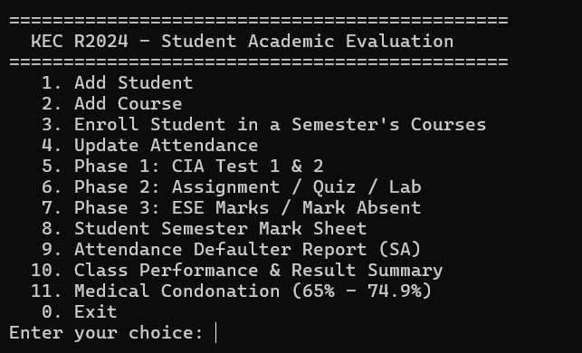

STUDENT & COURSE MANAGEMENT:

STUDENT REGISTRATION:
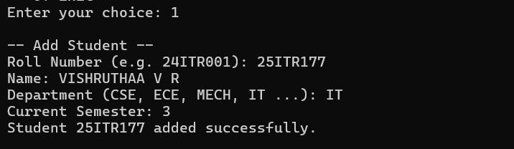

COURSE CATALOG:
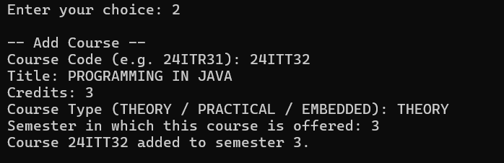

COURSE ENROLLMENT & ATTENDANCE TRACKING:
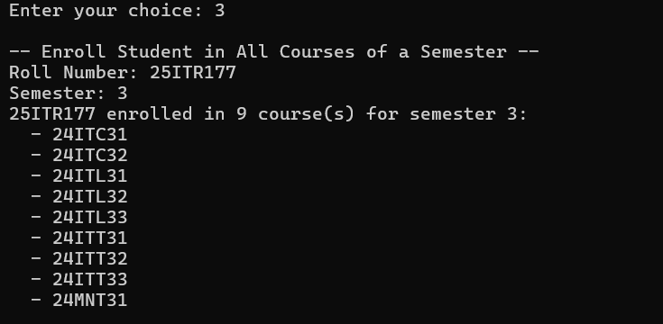

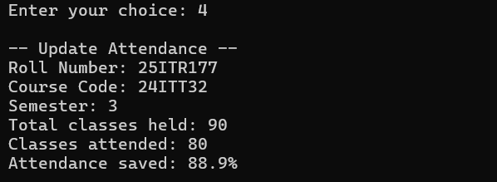

INCREMENTAL MARKS ENTRY:

PHASE 1 (MID-SEMESTER):
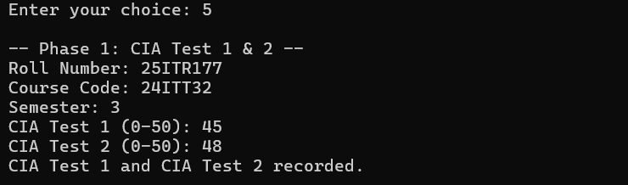

PHASE 2 (END OF SEMESTER - CIA):
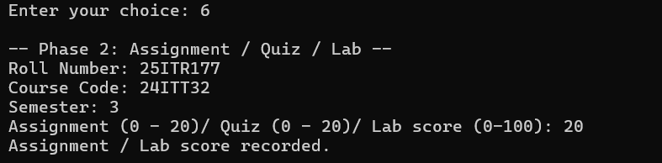

PHASE 3 (POST SEMESTER):

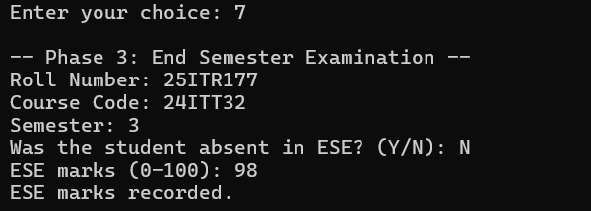

ATTENDANCE & GRADING RULES:

ATTENDANCE DEFAULTERS AND MEDICAL LEAVE CONDONATION:

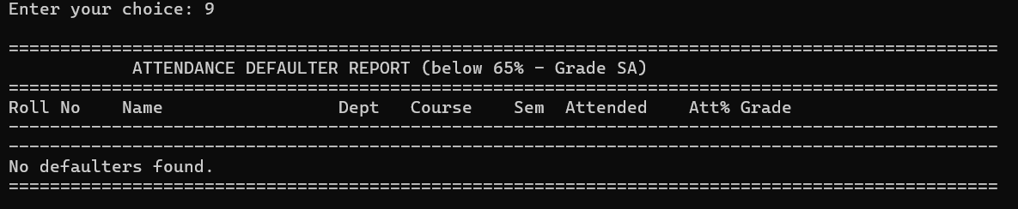

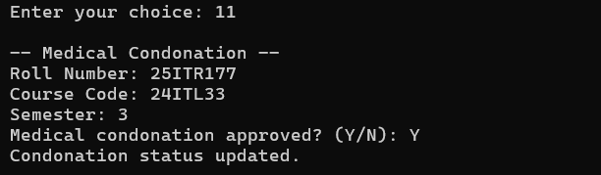

STUDENT SEMESTER MARK SHEET:
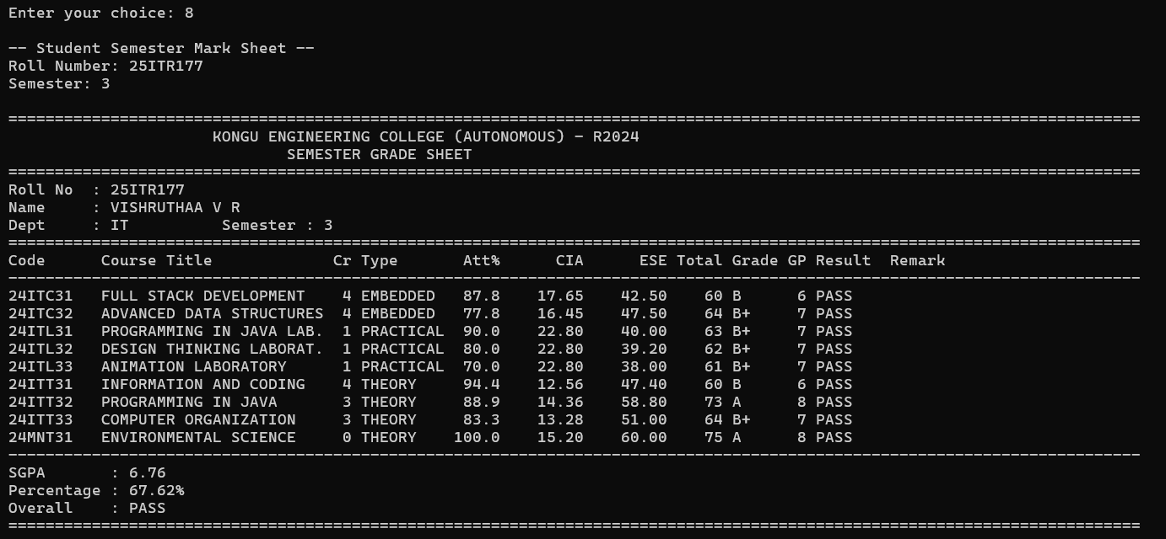

DEPARTMENT WISE CLASS PERFORMANCE & RESULT SUMMARY:

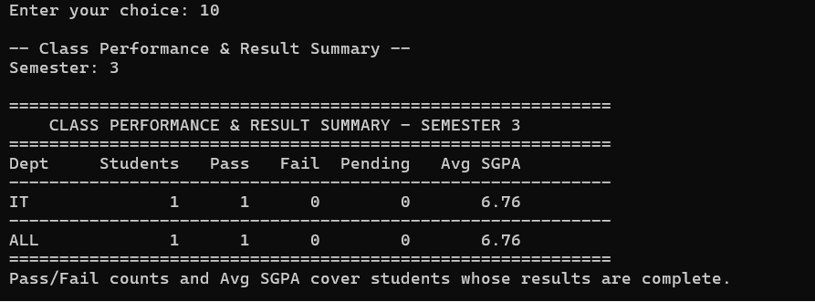

DATABASE:

STUDENTS DATABASE:

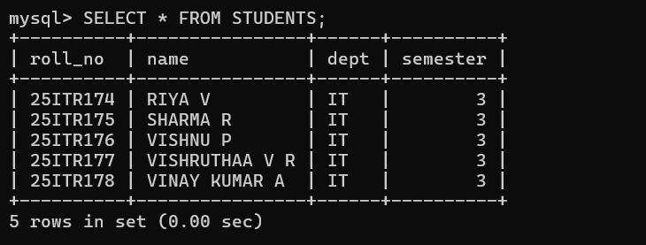

COURSES DATABASE:
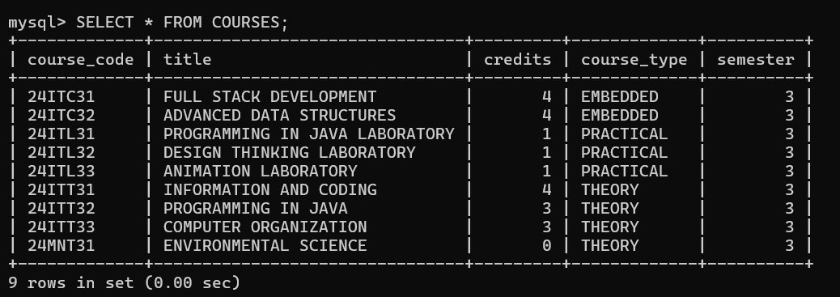

ENROLLMENTS DATABASE:
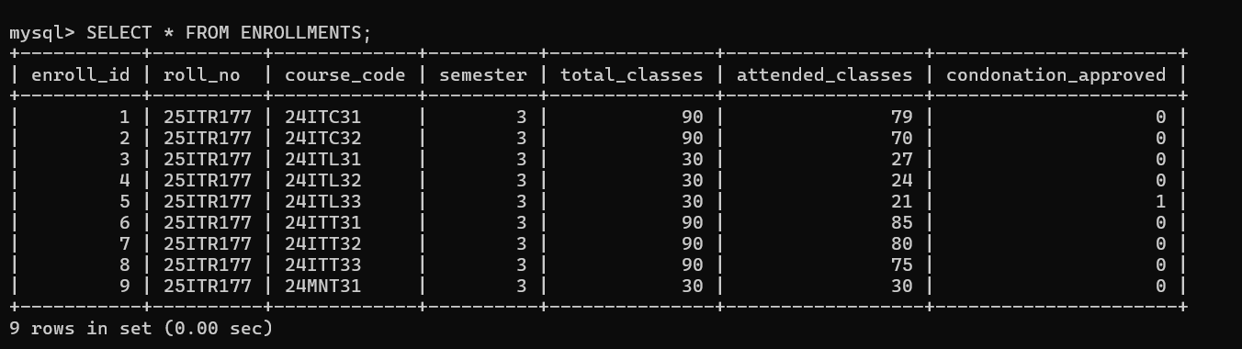

RESULT:

Thus, The Student Academic and Continuous Evaluation System for Kongu Engineering College (Autonomous) Regulation 2024 was successfully designed, developed, and tested using Java (JDBC) and MySQL. The system accurately automates the calculation of Continuous Internal Assessments (CIA), End Semester Examinations (ESE), Letter Grades, Attendance Eligibility, and Semester Grade Point Average (SGPA).

REFERENCES:
- JDBC Basics (Oracle Java Tutorials): https://docs.oracle.com/javase/tutorial/jdbc/basics/index.html
- Using Prepared Statements (Oracle Java Tutorials): https://docs.oracle.com/javase/tutorial/jdbc/basics/prepared.html
- MySQL Connector/J Developer Guide:
https://dev.mysql.com/doc/connector-j/en/
- MySQL 8.0 Reference Manual, FOREIGN KEY Constraints: https://dev.mysql.com/doc/refman/8.0/en/create-table-foreign-keys.html
- MySQL 8.0 Reference Manual, CHECK Constraints: https://dev.mysql.com/doc/refman/8.0/en/create-table-check-constraints.html
- KEC R2024 Curriculum and Syllabus: https://academic.kongu.edu/#/regulation/2024/b-e-b-tech-i-viii-semester

GITHUB:

LINK: | https://github.com/Vishruthaa01/StudentEvaluationSystem

